Female Genital Mutilation teacher’s resource
: Teac
Introduction: Up to 140 million girls and women worldwide have had their genitals mutilated in a practice that has no benefit whatsoever.
Objective: To encourage pupils to discuss the issue of female genital mutilation
Outcome: To consider the consequences of female genital mutilation and explore action to raise awareness
Activity | Resources | Curriculum links
Starter  - Learners vote on which statements are myths or facts about female genital mutilation. | PowerPoint  Activity sheet 1 | Subject: KS3/4 Citizenship and PSHE
Main  - Learners read through the stories of Atuko, Christine, Rosaleen, and Janet and Theresa.  - Using information from the stories, complete a ‘consequence chart’ for a girl who has undergone female genital mutilation and a girl who hasn’t.  - and/or  - Using information from the stories, complete the Diamond 9 activity. | Case studies  Activity sheet 2: Consequence chart  Activity sheet 3a&b: Diamond 9 statements | Subject: KS3/4 Citizenship and PSHE
Plenary  - Learners choose to:  - Prepare a Q&A for a community meeting  - Write to a local government official to ask for more resources to reach remote communities  - Write a newspaper article or blog post for the local community  - Ask pupils to share their work and give feedback on how persuasive their writing is. |  | Subject: KS3/4 Citizenship and PSHE
Additional  - Learners can complete the word search as a way of reinforcing the message that female genital mutilation is unnecessary. | Activity sheet 4: Word search

Female Genital Mutilation/Activity Sheet 1 – Myth or Fact? answers
Instructions: Read each statement out loud or show them on a whiteboard using the PowerPoint. Ask pupils to vote on whether each statement is a myth or fact.
Female Genital Mutilation/Activity Sheet 2 – Consequences chart
Instructions: In the first box, write your issue, e.g. Christine was forced to have female genital mutilation as a 15-year-old. Then in each box after, write the consequence of the previous action. How does the original action impact on Christine and her community?
Female Genital Mutilation/Activity Sheet 3a – Diamond 9
Instructions: Read through the context and complete the task
Context:
As an employee of ActionAid Kenya, you are working with colleagues globally to eradicate female genital mutilation. ActionAid Kenya’s country director has asked you to work with a rural community who are still keen to have their girls genitally mutilated.
To help you plan your programme, you have been given seven activities that are used by ActionAid and are known to have a positive impact on changing attitudes towards female genital mutilation. You must also come up with two of your own activities (you do not need to supply a price).
Task:
1. Cut out the nine activity statements on the next page.
2. Choose one of the scenarios given below.
3. Rank the activities in order of importance in terms of what’s needed to achieve the scenario, using a diamond 9 (see right).
4. Be prepared to explain why you have ordered them in the way you have.
5. Compare your order with the person sitting next to you. Are there differences? Why?
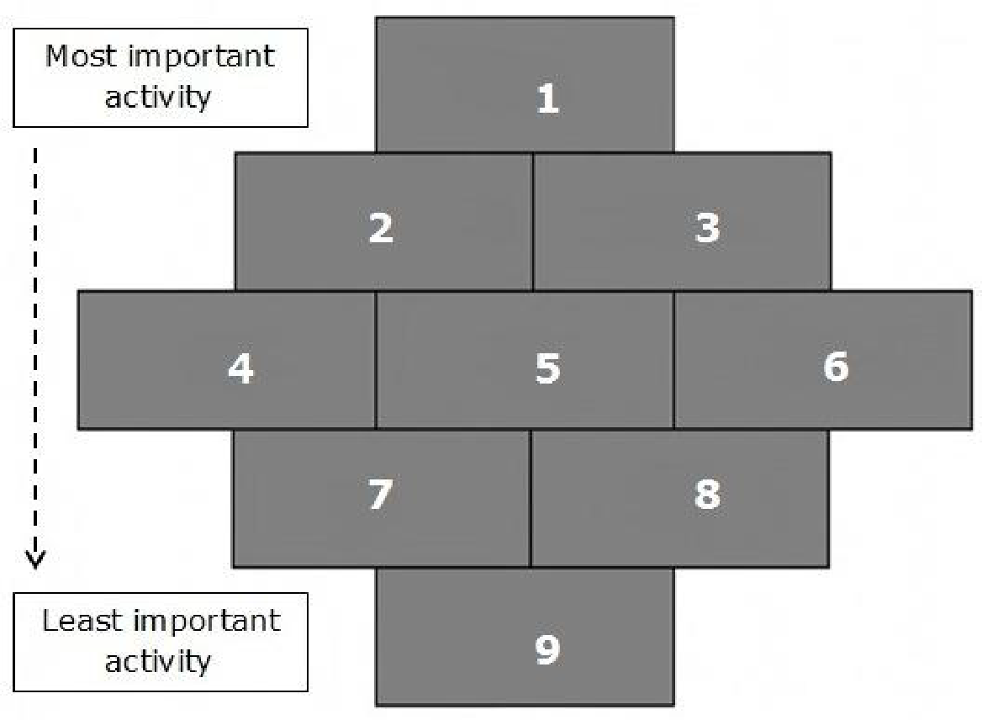
Would either of you change the order of your activities?
Extension
6. Choose another scenario and rank the activities accordingly.
Scenarios:
a. Forming a relationship with a community who have not met you before
b. Reaching the largest number of people in the community
c. Long-term strategy
d. Short-term strategy
e. Focusing on young people in the community
f. Focusing on men in the community
g. Most effective in terms of cost and reach
Female Genital Mutilation/Activity Sheet 3b – Diamond 9
Instructions: Cut out the cards and arrange in order of priority using the context and task given on the previous sheet
Female Genital Mutilation/Activity Sheet 4 – Wordsearch
Instructions: Find the hidden words related to female genital mutilation
Female Genital Mutilation/Further information
ActionAid works with communities across Africa to end female genital mutilation. You can get more information, support and advice about female genital mutilation in the UK from:
Childline
Daughters of Eve
Foreign and Commonwealth Office
NHS
NSPCC
The Metropolitan Police Service has a dedicated service for girls at risk of female genital mutilation. Call their Child Abuse Investigation Command/Project Azure on 020 7161 2888.

